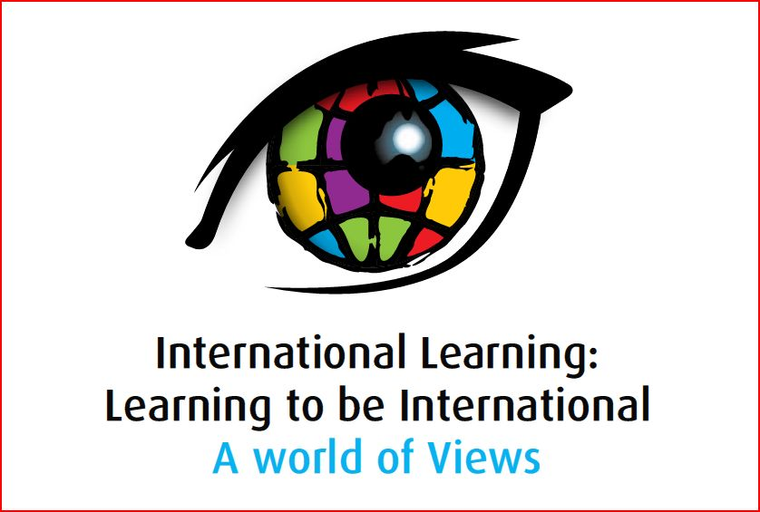

Presentation Abstract

Strand 5: Technology and International Learning
Presenter | Transformation or Confirmation of Timeless Notions?  Abstract
 | Crossing borders with digital technologies: connecting teachers and students with resources that employ Web 2.0  Students today have ready access to Web 2.0 technologies and applications. Social networking sites, twitter, ‘google’ earth, and online games challenge the borders of the world where students can interact and communicate with anyone they wish. Multi-platform personal technologies give our students immediate connection to communities outside their local environment, culture group and language. More importantly, students are just not passive viewers and connectors they are increasingly becoming the producers of cyber content.  A major consideration for this generation of students (and young teachers) is visual multi-media to engage, entertain and connect. Re-purposing television and film offers a new way of engaging students in conversations about people and places that are unfamiliar. Integrating these digital resources with Web 2.0 applications offer students a new way perspective of connecting with the world.  The Australian Children’s Television Foundation (ACTF) has been working with different education and cultural partners to develop digital learning resources that use digital clip formats aligned with suggested teaching activities to engage students with multimedia, support all disciplines and address topics and pedagogical frameworks related to current curriculums. Screen Asia is a free online resource that allows teachers and students to explore topics of relevance. It offers film text from documentary, drama and animation and includes Kahootz 3 Xpressions that have been developed as a response to key concepts and ideas. These 3-D animations also import the language and expression of children telling their stories.  The ACTF also promotes digital authoring by students to synthesise and apply their knowledge and understanding into a ‘new package’ as a digital response. This can be shared (virtually or print based) and delivered as part of their personal (e) portfolio. It is important for students to develop the necessary skills and aesthetic intelligences to make their virtual content comprehensive and explicit to easily communicate meaning.
  Deborah Cohen
  Education Manager
  Australian Children’s Television Foundationn
  deborah.cohen@actf.com.au
  98031330

