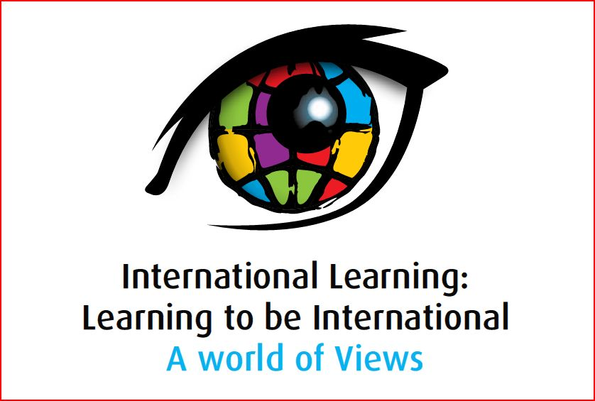

Presentation Abstract

Strand 2: Drivers of International Learning
Presenter | Transformation or Confirmation of Timeless Notions?  Abstract
 | Engaging and innovative ideas and approaches to address global issues and find solutions,: Empowering the global citizens of tomorrow  Without peace how can we successfully solve humanity’s global challenges? In the 21st century, peace is becoming increasingly more relevant: without a world that is basically peaceful, we will not be able to address our global challenges of climate change, decreasing biodiversity, lack of freshwater, and overpopulation.  Whilst there is a wealth of peace education material available to teachers, most of it relates to resolving conflict, in the classrooms, homes and communities. Very little study and education focuses on developing an understanding of peace and its relevance in our globalized world. In order to understand peace we need to first define it, and then measure it.  This presentation will focus on approaches to explore how  peace affects our daily lives, our world, and the global economy. It will discuss how students can be engaged in understanding the value of peace to our society and economy, and measuring levels of peacefulness in societies. It will demonstrate how these concepts can be thought in classrooms in innovative and engaging ways, using video, online resources, empirical data, photography and other resources that relate personal experience to global issues.  Four models will be presented to examine:  the notion that peace is more than the absence of war, with an exploration of the factors that influence the peacefulness of a country  the impact of peace on global sustainability with a focus on water  the contribution of education to the peacefulness of a country, and,  the benefits of peace to business and the economy, through an exploration of tourism and retail.
  Clyde McConaghy
  Director, Institute for Economics and Peace
  cmcconaghy@visionofhumanity.org

