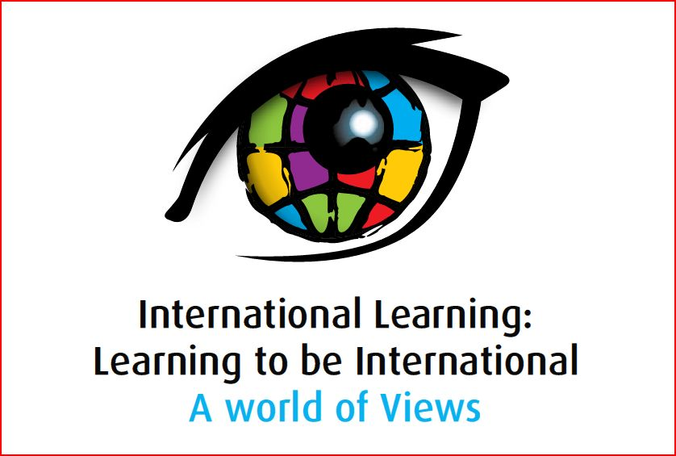

Presentation Abstract

Strand 3: Identity Formation/Reflection
Presenter | Transformation or Confirmation of Timeless Notions?  Abstract
 | Historical Reflections on the Worldview and the Identity  Three eras of globalization have witnessed the rise of international education and yet little is known about the earliest stirrings of the movement to align schooling with an emerging interdependent world. This is especially true of the faces, the fanfare and the failures of international education from the Victorian Age through the rebuilding that followed the Second World War. Of special interest to this presentation is the period from the Victorian Age to the dawn of the Atomic Age, a time when the very first institutional, research and political efforts emerged that tried to determine the implications of a global worldview and identity on nascent national systems of education. This presentation will focus on briefly describing the expressed worldview and identity characteristics of several major figures of the period 1851-1950 in international education including; Charles Dickens (UK), Richard Cobden (UK), Herman Molkenboer (Dutch), Adolphe Ferriere (Swiss), Rabinranath Tagore (Indian) , Franz Kemeny (Hungarian), F. Fern Andrews (US) , Edward Peeters (Dutch), Paul Geheeb (German), Elizabeth Rotten (Swiss), and Issac Leon Kandel (USA).
  Bob Sylvester
  Associate Professor
  Elementary and Early Childhood Education
  Bridgewater State College
  Bridgewater, Massachusetts, USA
  RSylvester@bridgew.edu

