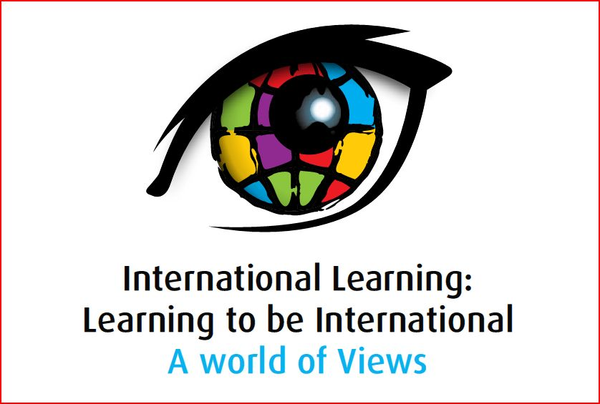

Presentation Abstract

Strand 6: International Learning, Social Consciousness and Action

Presenter | Transformation or Confirmation of Timeless Notions?  Abstract
Thaura Atta  Upper Hand Development Organization  Sudan  Email - thaura2001@yahoo.com | Sustaining Civil Society: Teaching Children’s Rights for Basic Students
  This paper describes in detail a 16-week course designed to teach basic children’s rights to students aged 10-12. By the end of this
  course, each participant should have
  1) Learned more about their rights in relation to:
  o Education
  o Health
  o Play
  o Anti-Discrimination
  o Violence
  o Female Genital Mutilation
  ) Developed interpersonal skills through group presentations and the class play
  3) Improved communication skills through weekly workshops and group activities
  4) Learned to foster the value of tolerance and teamwork
  5) Been able to present in a class play the perceptions and ideas on basic children’s rights derived from the course
  6) Improved learning and performance skills
  so we could chose 18 schools from many culture and see the students with drama and dance and can singers with talent for
  delivery the messages that come from works shops in the topic we want like ( education/ health/ violence etc… .
  We need students with talent / organize workshops / messages from work shops / scenarist/ director/ dance coach
  All of them could work for the conversion of messages into a form of drama /dance / and singing.
  2/ Train the children that we chose them from the 18 schools
  3/ And now stage performance on the stages of schools
  4/ Monitoring Evaluation
  Will be written by the distribution of evaluation forms before and after the program and will compare the result by 18 schools
  did not participate in this program to get the final result of this program

