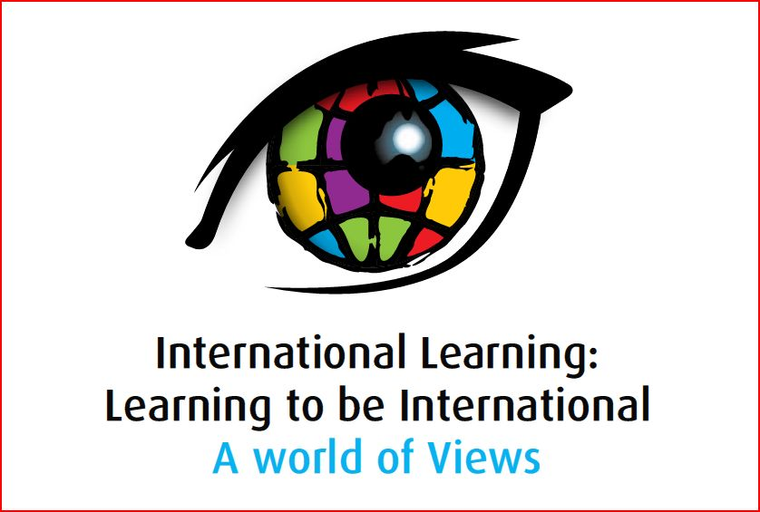

Presentation Abstract

Strand 2: Drivers of International Learning
Presenter | Transformation or Confirmation of Timeless Notions?  Abstract
 | The impact of school partnerships: research-based evidence from schools in the UK, Africa and Asia  I am part of a consortium which manages a £23m school partnership programme funded by the UK government. Our task is to initiate, by 2012, 5000 partnerships between schools in the UK and schools in developing countries.  School partnerships are vehicles for educating our students to be global citizens, which will enable them to breach the local and reach the global. International education can challenge the structures and systems within which we live, so that we look beyond the local and national to an interdependent world. Such a vision is essential if we are to bring peace to the ‘battleground of the twenty-first century’ where fundamentalism is pitted against ‘cosmopolitan tolerance’ (Giddens, 1999).  In 2006 I proposed to the UK Department for International Development that we assess the impact of their school partnerships programme. Was the programme reinforcing stereotypes? Was it perceived as another form of colonialism by our partners in Africa and Asia? I participated in the study in an advisory capacity, and subsequently I have developed a three-dimensional model for capturing the impact of the programme in areas such as the development of cultural awareness and appreciation of difference. The research involved two stages; a quantitative survey covering 800 UK and 800 African and Asian schools, and 55 qualitative case-studies. The influence of school partnerships on teachers and students has been evaluated. 72% of the UK respondents and 89% of the African and Asian respondents agreed that the partnership ‘positively influenced involvement of students, teachers the whole school and the community [in] educational issues and improvement’. Particular elements associated with successful partnerships are identified, which offer useful guidance when developing a partnership model.  The paper will reflect upon and develop these points.
  Angela Cook
  Director, Cambridge Education Foundation,
  Tel: +44(0) 208 368 4019
  Mob: +44(0) 7720 599 767
  Main office: +44(0) 1223 463028 / 578500
  Fax: +44(0) 1223 578501
  Cambridge Education,
  Demeter House,
  Station Road,
  Cambridge CB1 2RS.
  Angela.Cook@camb-ed.com

