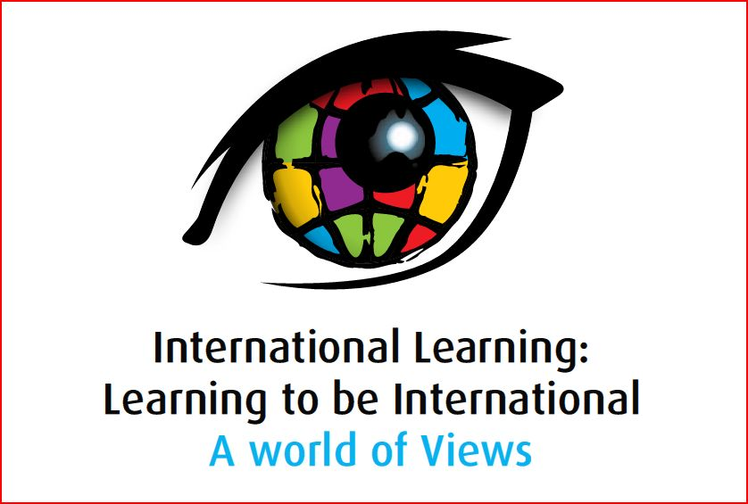

Presentation Abstract

Strand 1: Curricular Approaches to International Learning
Presenter | Transformation or Confirmation of Timeless Notions?  Abstract
 | Breaking the cycle: Global awareness through global connectedness  The Victorian Department of Education and Early Childhood Development recognises that the “internationalising” of school education is increasingly important to equip all young people with the skills and capabilities they will need for economic, social and cultural success in the 21st century.  The Department has a vision for international education – that it is embedded in the daily life of schools, thereby preparing Victorian students as citizens for active interaction in an interdependent globalised world and, in doing so, contribute to improved student outcomes.  To contribute to this vision, the Department is committed to providing opportunities for students, teachers and school leaders to engage across other languages and cultures.  In 2009 the Department developed an education program to support a 20,000 kilometre cycle journey across Africa by adventurist Kate Leeming. The purpose of Kate’s expedition, Breaking the Cycle, is to learn firsthand about the causes and consequences of extreme poverty, and through the story of the expedition which unfolds, educate and inspire actions which will assist in making communities more sustainable and resilient to the issues. The expedition, which commenced in October 2009 and is expected to conclude in July 2010, is closely aligned with the Millennium Development Goals.  The educational program consists of:  • four interdisciplinary units with an integrated approach to middle years learning, and  • an online collaboration site (Ning) to facilitate schools’ participation in the project and for teachers and schools to communicate, collaborate and share resources, ideas and enthusiasm.  One of the Victorian schools who are participating in the education program will present their experience of the education program, including how it has enhanced students’ international-mindedness through deepened awareness and understanding of African cultures, geography, environmental sustainability and the causes and effects of extreme poverty. The schools’ use of the online platform will also be explored.
  Andrew Willimott & Kerry Rowett
  Mr Andrew Willimott
  Senior Policy Officer, International Education Division
  Victorian Department of Education and Early Childhood Development
  willimott.andrew.g@edumail.vic.gov.au/ 03 9637 3457 | F: 03 9637 2184
  Ms Kerry Rowett
  Client Liaison Officer, eLearning Unit
  Victorian Department of Education and Early Childhood Development
  rowett.kerry.k@edumail.vic.gov.au
  (03) 96513103
  David Clift
  clift.david.d@edumail.vic.gov.au

