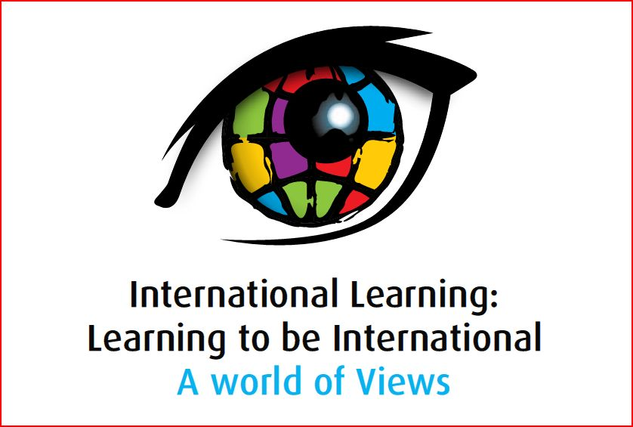

Presentation Abstract

Strand 4: Culture Learning
Presenter | Transformation or Confirmation of Timeless Notions?  Abstract
 | Peace Building Activities in 20 schools of Pakistan  The Situation  Pakistan is a country where religious violence happens repeatedly, greatly affecting all parts of the society, from peasants up to the policy-making heads. The daily lives of Pakistani people are guided by misconceptions of religion. Islam is elevated and other religions are despised. Religious prejudice affects all of our interactions, whether social, economic or political. This project will strive to instill concepts of peaceful solutions in our children. We have targeted peace building activities in 20 schools of Faisalabad, Chak Jhumra and Gojra.  Even our laws do not always promote peace. Starting from the Resolution in 1949 (the country’s first legal document which played a vital role in the formation of the constitution of Pakistan in the coming years) and continuing with the blasphemy law (Hudood Ordinance), religious intolerance is built into our way of life. The system, declares Ahmedies (a fraction claiming themselves non-Muslims) as not able to hold office. Many more state-sponsored discriminatory legislations pervade our governmental system. It is not surprising that the common people have also adopted attitudes of intolerance.  Ninety-five of Pakistanis are Muslim, having various sects. The active leaders of the sects have strong holds on the common people. Some of the more extreme leaders try to influence the people toward violence to promote their particular religious beliefs.  The brain washing process is continued not only through religious institutions, but also through media and even the school syllabus. Religious extremists have taken control of the situation, using religion as a tool.  Our children do not get the opportunity to understand the themes of peace, reconciliation, love and conflict resolution, so immersed are they in the “virtues” of violence. They are taught that virtue is to do good only to followers of their own religion or sect. The school syllabus emphasizes only certain religious practices. The schools deter children from tolerance to the religious beliefs of the other faiths.  We have not learned, as a country, to get along with people of differing religious beliefs. Our children are the most vulnerable; they learn intolerance in school. Also, the values they learn from their particular sect become strong parts of themselves. In many schools, the children of different sects do not even like to drink from the same glass. This secludes them to form their own parties as Sunni, Shiates, and Ahmedies. They do not mingle with one another because each one feels that they are better than the other. This division roots itself into the minds of the children, and a very sensitive class of young people move toward terrorism.  In many cases, Muslim children mistreat the minority children. Christians are called Assai by other sects, a title that demeans them as lower class citizens. Before 1987, a bill was presented in the national assembly requiring separate dress for the minorities—black clothes for minorities, white for the majority. In 1993, minorities were required to line up in a separate column from Muslims and their National Identity Cards also presented.  These situations have caused many parents of minority children to keep their children out of schools belonging to the majority. They fear that their child will not learn anything except hatred and intolerance. Parents are afraid for the future of their children. That is the conclusion of a survey taken by HDO for three months at different schools. Our conclusion is that there is an urgent need to work for peace in schools. We believe this proposed project can bring a new attitude of peace among differing sects and religions.  The Schools  The Peace Building project will initially target twenty schools in Faisalabad and Gojra & Chak Jhumra.  Schools in Faisalabad: (District Faisalabad)  1. Government Sabria Sarajia High School.  2. Government A.V Modern High School  3. Government M.C High School  4. Government Jamia Chishtia High School  5. Government Girls High School  6. Government Johar Public High School  7. Government Crescent Model High School  8. Government Comprehensive High School  9. Government Girl’s Grammar High School  10. Government City Muslim High School  Schools in Gojra: (District Toba Tek Singh)  1. Government M.C High School  2. Government Islamia High School  3. Government Ghousia Muslim High School  4. Government Girls High School  5. Government Girls Millat High School  Schools in Chak Jhumra: (District Faisalabad)  1. Government Higher Secondary School.  2. Government Girls High School  3. Government elementary School  4. Alfalah High School  5. Abdullah Grammar High School  Descriptions of the Communities  There are ten schools in Faisalabad District. The population of this city has grown from a few thousand in 1901 to over two million The population of the area where these schools are located is approximately 150,000. People work in offices, factories, drive donkey carts, kiln workers and labors. Women often work in the houses of the rich people.  Gojra was established in 1896 when colonization of Layallpur (Faisalabad) was started. The city has a population of about 140,000. This city is part of the Toba Tek Singh district. This town consists of a group of farming villages. People work in fields and get portions of the yearly crops as wheat, corn flour and sugar cane. Ninety percent of the country’s potatoes come from this area. This area is famous for its property disputes, which are based on caste and sect. Family enmity goes on for generations.  Chak Jhumra is a city with population of about 120,000. The city is surrounded by villages where people work in fields their living from the crops they grow. This city is also popular for the quarrels and enmities. Many people commute to Faisalabad for jobs to supplement income from stores and farms.  Why these Particular Schools?  HDO has focused on areas and schools that we consider to be the most vulnerable to religious bigotry and violence. Gojra, Faisalabad and Chak Jhumra are the places where situations have come up that have caused turmoil. In these areas, schools have been selected which are under the management of government. Most people do not like to send their children to the government schools. The only parents that get their children admitted into government schools are those who cannot afford the price of private school. The students are mostly from those families who believe in the caste system. Therefore HDO has selected government schools after a careful consideration in three target areas.  The literacy rate in Pakistan is 47.4 % as stated by UNESCO, while in the focused areas where the Peace Building Project will begin, it is hardly 10 %. Most of the uneducated, illiterate people are afraid they will be discriminated based on religious beliefs. If they are not of the popular Muslim sects, their children are not admitted into the schools easily, and if admitted, the other children are taught to shun them. They will not be allowed to drink water from the same hand pump and the teacher will not pay attention to them in the class. They are taught to believe that even if educated, they will not get good jobs unless they change religion.  We have chosen schools where the need for teaching peace principles is great.  Goals & Objectives:  1. To work at the grass root level, teaching children to promote peace and become aware of its importance in the society.  2. To give students an attitude of peace, not only in the schools, but also the communities they live in.  3. To involve parents so they participate in creating a peaceful environment.  4. To teach the values needed in a civilized society.  5. To begin a future where people unite and care for each other.  Our Proposed Method  We want to introduce notions of peace, interfaith harmony, and conflict resolution to children, teachers and parents in the schools, and equip them with nonviolent methods of conflict resolution. We want to promote negotiation and dialogue habits in the students. Our methods include joint activities among Muslims with their various sects, Christians, and other religions. We think the common forum of schools is a good place to start a movement which gathers people for inter-faith and peaceful community.  Students at these schools do not have the option to learn the concepts of peace and conflict resolution using non-violent methods. What they learn is to use the power to resolve all sorts of conflicts. It is a mixed group of Muslim and Christian children from grass roots communities. These children can easily become prey to the violent movements going on in the society. The idea is to introduce Peace along with their other learning.  At the beginning of the project there will be orientation meetings of the staff to establish plans of format and implementation for each school. We will then meet with the school principles. We want their cooperation and will give them full presentation in our planning.  We will establish a data collection system to better understand the needs at each school. An introductory form will be used to collect data from the students. We will ask each student about his/her impressions and attitudes and about the proposed project.  A Peace Committee of seven people will be formed to handle the overall project. There will be citizens from the targeted communities, school administrators, the Chairman and Vice Chairman of HDO. At the beginning of the project there will be an orientation meeting with school staff. They will be made aware of the format and the way we plan to implement it. The school principles and a few of the teachers will be involved in the details of the project.  There will be six animators to implement the activities in the schools in three cities. A Project Coordinator will keep a follow up to observe the progress and effectiveness of the activities.  For data collection and Impression HDO will use two types of forms,  1. Introduction form  2. Impression form  The introductory form will be used to collect the data from the students. This form will contain information about the students’ biography. The same form will also be used in all the schools. The second form will be used to learn impressions of the students, his attitude toward the project, and his own interest will also be measured through the data he will provide.  In all the schools, HDO will conduct brainstorming sessions with students. There they will be given handouts containing peace slogans, messages concerning peace, unity, love and solidarity and asked for their opinions on these things.  Students will be taught about peace through audio-video, and peace clips in video will be shown to them. These video clips will have the documentaries about peace issues and the loss of lives for religious issues in past.  Poster competition will be another activity to help students brainstorm what they have in their minds about peace and peace concepts. They will put those ideas on paper, which will guide them to know the deeper meaning of peace.  Peace walks will help to show oneness with world peace. Peace walks in school will also bring them closer to each other, and will be able to create an environment of friendship.  There will be a follow up of each activity, where students will be asked what they learned about peace. They will be given booklets of posters and other things they had made. They will be reminded of the things they have already learned from the peace classes.  Peace Conventions will be held in the three specific areas—Faisalabad, Chak Jhumra, and Gojra. There will be speech competitions, Peace Quiz and Peace walks. These peace conventions will help students to become friends, regardless of caste and religion.  Brainstorming Sessions/ Seminars:  Every week a session will be conducted in the class room. A trained teacher will give a presentation on peace, interfaith harmony and conflict resolution. The session will also be attended by teachers, who have little or no exposure to these concepts. The class will include basic ideas of peace, interfaith harmony and conflict resolution, stories related to these concepts, roles of children in promoting these concepts, and methods of applying them in our daily lives. Also included will be discussion on how children can unlearn the concepts of violence, intolerance and hatred.  Peace Symbols  Instead of playing with toys and games promoting violence, extremism and intolerance, students will gather the peace symbols in their daily lives. They will be encouraged to make workbooks having peace symbols. Students who develop the best books will be awarded prizes. A teacher in school will assist students in collecting the symbols of peace. Once a week he/she will take thirty minutes to ask students to make peace symbols by them. At the end of each month students will be rewarded for making the best symbols of the month.  Posters Competition & Essay writing  Poster competition will be an activity to help students brainstorm what they have in their minds about peace and peace concepts. They will put those ideas on paper, which will guide them to know the deeper meaning of peace.  The high school students will make posters showing the concepts of peace in a more involved way than the younger ones do. They will be given more freedom and may illustrate harmony and conflict resolution in the classrooms. The poster making will be the central part of the activity. These posters will be displayed on the school board, and the best poster will be awarded a prize.  They will also write essays examining the same themes. The students will be given topics on which to write 250 words.  Theatre  Theatre is another effective way of conveying messages. The students will be presented a situation for them to act out on stage. At the end of the performance, they will be asked to brainstorm the performance. This will help students to understand the message more precisely.  Tree Planting  We will organize a tree planting week for the Christian and Muslim students. In a colony where Muslims and Christians live together, children will carry out an interfaith activity. The children will clean the streets and plant flowers and small trees in the homes and on the streets. The name of the colony selected for this purpose is Chaman Zar Colony. The students will also try to involve the community in this activity.  Conflict Resolution Table  We think a good way to involve the children in what they have learned is through a Conflict Resolution Table. Children will sit down and talk about their problems with resolution as the goal. They will learn by experience the arts of negotiation and dialogue. The teacher will only facilitate this dialogue. After resolving a conflict, the children will light a peace candle to declare that the conflict has been resolved. A teacher will be trained to play the role of middleman whenever the process breaks down.  Peace Walks  We will organize peace walks, where banners made by the children will be carried in public. Peace walks will help to give them an understanding of oneness with world peace. These walks will also bring them closer to each other and create an environment of friendship.  There will be a follow-up of each project where students will be asked questions related to their learning about peace. This will be a time of evaluation both for themselves and their impact on society. We want the Peace Building project to eventually pass to the children who will carry it onward without our help.  Peace Conventions  We are planning three Peace Conventions. These will be in Faisalabad, Chak Jhumra, and Toba Tek Singh. These conventions will be held in the schools of the specific area. There will be speech competitions, a Peace Quiz and Peace Walks. These peace conventions will help students to become friends, regardless of caste and religion.  Joint Celebration  As a token of harmony and love, the Christian and Muslim students and teachers will celebrate the religious events of both communities together. They will exchange gifts and will eat together. Four such programs will be held on Christmas, Eid–ul-Fitr, Eid-ul-Azha and Easter. These programs will help develop the understanding of the students and teachers from both religions.  Grand Peace Walk:  We want to have a Grand Peace Walk involving all the schools in one big celebration. There will be banners with peace slogans. This walk will travel through the popular areas of Faisalabad.
  Rashad Javed
  Hope Development Organization
  Street # 2, Office # 991, Chaman Zar Colony, Faisalabad-Pakistan
  chairman@hopedevelopment.org
  92 41 2011728 or 92 307 484 3004

